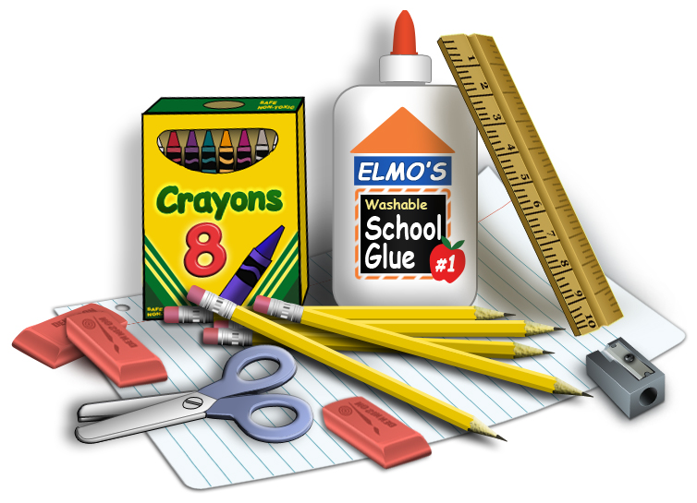

**Dr. Freeman’s (Room150)**

**4th Grade Supply List**

3 Notebooks (Composition)

Pencils (#2 – No Mechanical)

Scissors

Eraser

Glue Sticks

Coloring Pencils

Earbuds or Head Phones

Hand Held Pencil Sharpener with catcher

Individual Sanitizer (for student)

Wish List

Hand sanitizer

3 boxes of tissue

Disinfecting wipes